Computer System
Technical Documentation
(Sample-confidential)

Enterwise Technology - 2005

For more information or additional samples,
please contact:

Jeff Strickland
info@enterwisetechnology.com

Note: The information contained within this document
is for illustrative and promotional purposes only.

Table of Contents
Purpose 5
Important Phone Numbers 5
Accounts 5
Router and DHCP Information 5
Router Login 5
Router Configuration 5
Server Information 6
Hardware summary 6
Addressing 6
Backup Information 7
Command 7
VPN Access Setup Summary 7
User Accounts on Server 7
Router Configuration Detail 8
Dell Server Support Information 9
Original Dell Server Configuration 9
Recommended Bi-Weekly Maintenance 10
Server 10
Workstation 10
Adding the Main HP Color Printer 10
PC Documentation 11
Melvin 11
Tom 11
Karen 12
DHCP and WINS Information 12

Purpose
This document is primarily for systems technicians, but can assist in setting up remote access and other functions.

Important Phone Numbers
Time Warner – Road Runner: 943-9999 (Wendy: 378-9999)
Computer Support: Jeff Strickland 332-9999 (h) or 965-9999 (m) OR
Craig Davis: 841-9999 #309 (w) or 398-9999 (h)
HTT: 375-9999 (Tom, Karen, Jenifer and Amy)

Accounts
User | Access PW | PC Name | Notes
Administrator |  | Server | Main server: 192.168.1.2
Krush |  | karen
Trush |  | trushs
Jrush |  | jenifer | Fixed address 192.168.1.200
Riley
Amy |  | amy
Rrcambe |  | Ronniescomputer
Melvin |  | Melvinpc

Router and DHCP Information

Router Login
http://192.168.1.1

Router Configuration
Firmware Version: 1.44.3, Dec 24 2002 (Linksys Model BEFSX41)
Main outside address: xx.xx.xx.xx (for remote desktop & VPN)
IP Address: 192.168.1.1 (SERVER address 192.168.1.2)
Subnet Mask: 255.255.255.0
DHCP server: Disabled (DHCP scope on server begins .150-185)
Firmware Version: 1.44.3, Dec 24 2002
Current Time: Mar. 10 2005 Thu. 19:24:35
WAN: (MAC Address: 00-06-25-E3-AD-F2)
IP Address: xx.xx.xx.xx
Subnet Mask: 255.255.255.252
Default Gateway: 83.172.73.145
DNS: 83.25.5.60
83.25.5.61

Server Information

Hardware summary
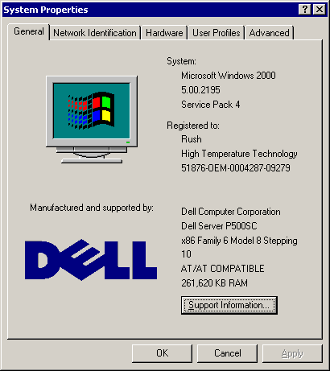

Addressing
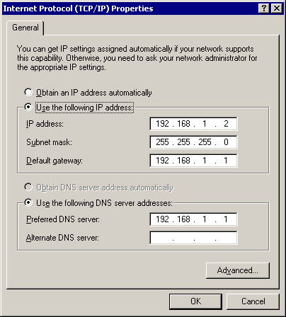

Backup Information
Backup used is NTBACKUP which is scheduled from “Scheduled Tasks” in control panel and runs the following command (may paste into the scheduler).

Command
C:\WINNT\system32\NTBACKUP.EXE backup "@c:\fullbackup.bks" /v:no /r:no /rs:no /hc:on /m normal /j "Daily Backup" /l:s /p "Travan" /um

VPN Access Setup Summary
Using Windows 2000 or XP, from the “network” icon in control panel:
Add a new connection, VPN, do not dial, name=HTT with address of xx.xx.xx.xx You will need to enter your ID and Password when connecting the first time.

Note that if your PC is setup for remote access (must be XP Pro, you may use the Remote Desktop Connection program under Accessories-Communications to connect to your desktop (use your computer name and RDP port if given (i.e. jenifer:)

If you are running Windows 2000 as a remote computer, you will need to download the “remote desktop client” from www.microsoft.com (enter remote desktop client in the search field).

User Accounts on Server
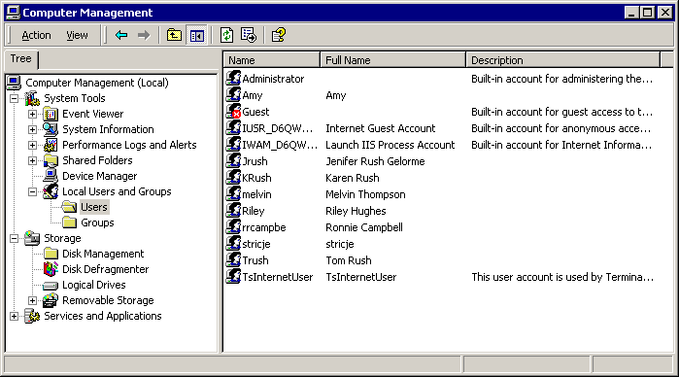

Router Configuration Detail

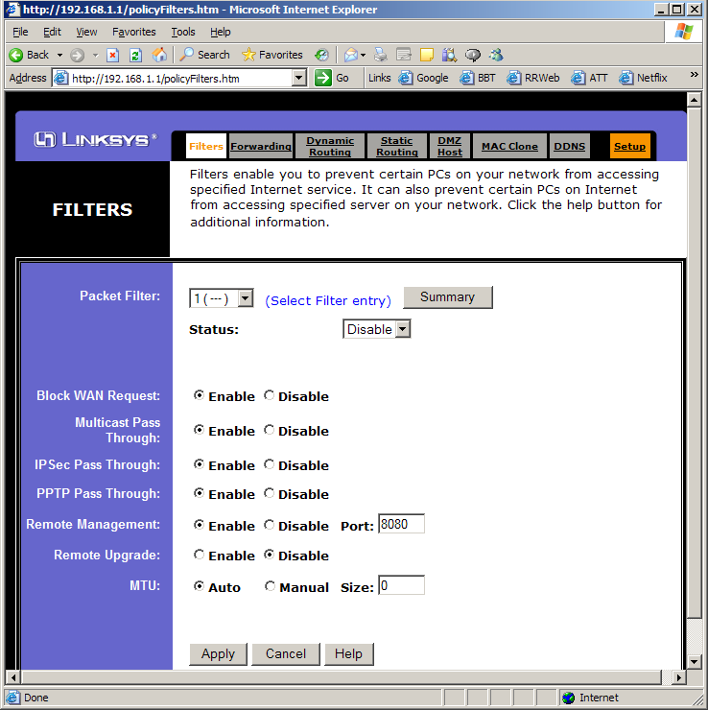

Dell Server Support Information
Use this number: 6QWH011 146-873-554-93 when calling Dell for technical help.

Original Dell Server Configuration
System Summary

Service Tag: 6QWH011
System Type: PowerEdge 500SC
Ship Date: 11/12/2001
Dell IBU: Americas

Quantity Parts # Part Description
1 1G599 ASSEMBLY, CABLE, DORADO/ATHENS/TUALATIN/ALMODOR, FLOPPY DRIVE, PE500SC
1 3J283 CARD (CIRCUIT), PLANAR (MOTHERBOARD), VIDEO/NIC, PE500SC, 2
1 5G815 ASSEMBLY, CABLE, ATA100, 2DROP, P500SC, 1
1 6E233 PROCESSOR, 80526, 1GHZ, 256, FIBER CHANNEL, COPPERMINE-TUALATIN, INTEGRATED HEAT SPREADER
1 8E918 ASSEMBLY, CABLE, ATA100, 2DROP, P500SC, 2
0 3260R PREPARATION MATERIAL, DEV, SRV, DCRS #1
1 5120P CORD, POWER, 125V, 6FT, SPT2, UNSHIELDED
1 955FM MOUSE, PERSONAL SYSTEM 2, 6P, 2BTN, LOGITECH, MIDNIGHT GRAY
1 95FEM KEYBOARD, 104, 6P, UNITED STATES, NMB, RUBBERDOME, DELL MIDNIGHT GRAY, SMALL BOX
2 5C667 DUAL IN-LINE MEMORY MODULE, 128, 133M, 16X72, 4K, 168, RGS
1 0E047 COMPACT DISK DRIVE, 680M, I, 5.25" FORM FACTOR, HALF HEIGHT, NO CONTROLLER/NO CABLES, 48, BLACK, SMSN
1 8G576 HARD DRIVE, 40GB, I, 7.2K, 20/P, IBM, ENTERPRISE SYSTEMS GROUP
1 7F454 FLOPPY DRIVE, 1.44M, 3.5" FORM FACTOR, 3MD, NO BEZEL, NEC CORPORATION, 418, MIDNIGHT GRAY
1 1E028 OVERPACK KIT, WINDOWS 2000, SP2, ENGLAND/ENGLISH, WORLD WIDE

Recommended Bi-Weekly Maintenance

Server
- Check disk space and search for large files (F3, D:, search by size)
- Remove temp files (*.TMP) and run Disk Cleanup utility
- Check backups and logs (perform test restore if time permits)
- Check disk based backups
- Defragment hard drive
- Check event and system logs
- Check server hardware health

Workstation
- Run disk cleanup (cleanmgr /sagerun:200)
- Run chkdsk and defrag hard drives

Adding the Main HP Color Printer
The main color printer is on address 192.168.1.25 It may be added to a workstation (local or remote via VPN) by adding a “local printer” with a TCP/IP port of 192.168.1.25.

PC Documentation

Melvin
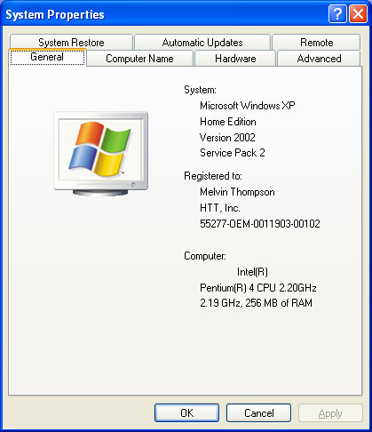

Tom
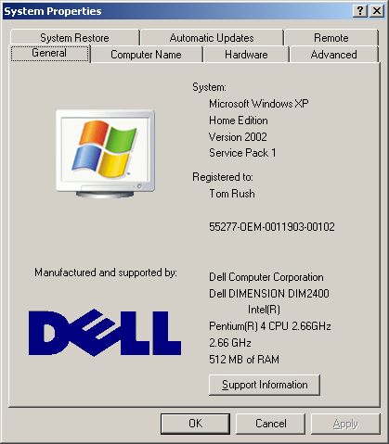

Karen
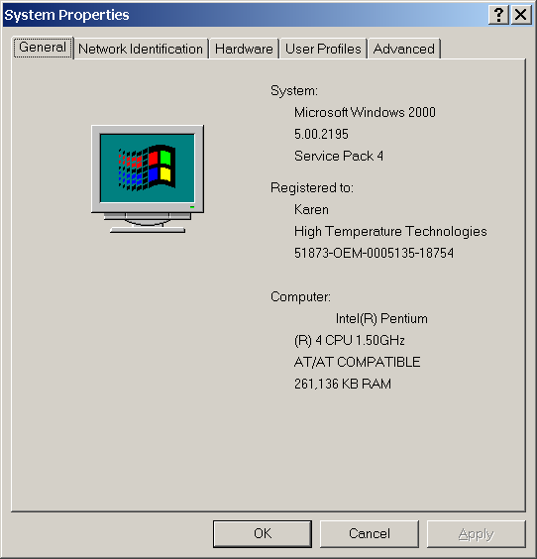

DHCP and WINS Information
A DHCP server runs on the server and gives out workstation addresses:
192.168.1.150 thru 192.168.1.185

DHCP on the router is turned OFF.

The server is also a WINS server for improved name resolution.

We may later go to static addresses for the computers.

Jeff Strickland

